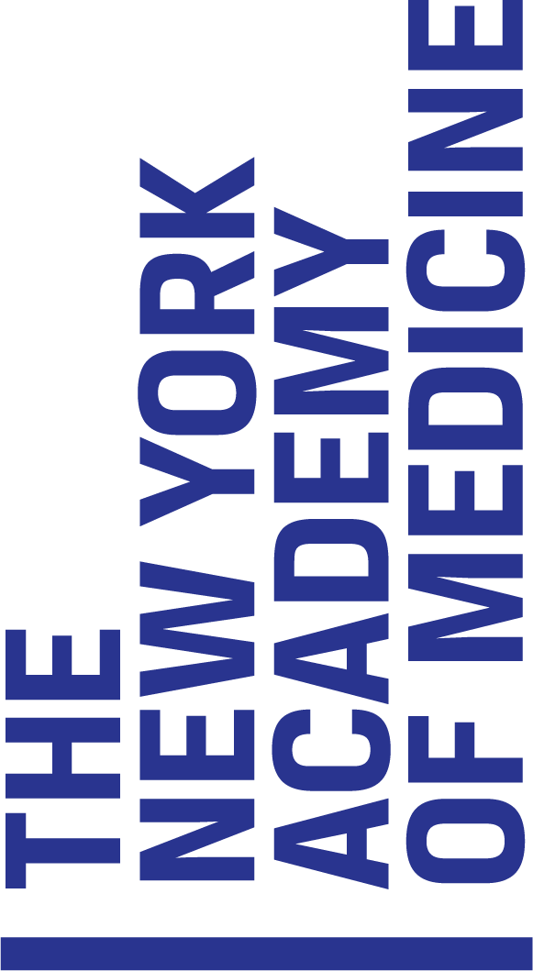

Title: Director of Fellows Program

Department: Fellowship & Research Endowments
About The New York Academy of Medicine:

The New York Academy of Medicine is a leading voice for innovation in public health. Throughout our 176-year history, we have uniquely championed changes to the systems that perpetuate health inequities and that keep all communities from achieving good health. Today, this work includes innovative research, programs, and policy initiatives that distinctively value community input for maximum impact. Combined with our trusted public programming, historic library, and with the support of our esteemed Fellows and Members, NYAM’s legacy as a public health leader moves boldly forward.

Department Summary:
NYAM's prestigious Fellows program is the foundation on which the Academy was established in 1847. Our Fellows are distinguished professionals in medical and health professions and other disciplines affecting health. They embody the highest levels of achievement and leadership in areas that span a wide range of disciplines, including medicine, nursing, social work, public health, administration, health policy, pharmacy, dentistry, law, and government, and are academics, practitioners, and policymakers in their fields. NYAM also offers membership levels for early career professionals, graduate students, and recent graduates in the health professions and related fields.

Position Summary/Overview:
Reporting to the President’s Office, the Director is responsible for the overall management of the Office of Fellowship and Research Endowments, including day-to-day operations, strategic direction, budget development, management of restricted and unrestricted funds and staff supervision and development. The Director works with colleagues collaboratively across the organization to foster active Fellow engagement and ensures that activities align with the Academy's mission and vision.

Essential Duties and Responsibilities:

Fellowship/Membership responsibilities include but are not limited to:

- Supports ~ 2,000 current Academy Fellows and Members in their respective Sections by discipline and fosters strong relationship with Section leaders and key stakeholders.
- Leads the recruitment and retention of members, including developing and implementing strategies to engage and retain members.
- Provides staff support for five-six annual meetings of the Committee on Admission and Membership (COAM).
- Manages all aspects of the membership program, including program logistics, budget management, and program evaluation.
- Oversees the annual dues collection process, in coordination with the Business Office.
- Manages the operations, policies and procedures of Sections and Workgroups including managing executive committee and business meetings, discipline-specific in-person and virtual programs.
- Manages the planning and implementation of the high-profile Annual Meeting of the Fellows.

Endowed Fellowship, Student Grant, and Symposia responsibilities include but are not limited to:

- Directs the process for awarding and implementing five annual Fellowships, three Student Grant programs and four Endowed Lectures. Works closely with the Selection Committees throughout the process from promoting applications through ensuring timely award payments.
- Develops alternating annual symposia.
- Other duties as assigned.

Qualifications:
- At least four years of related experience in an association or membership organization, academic health professional institution or not-for-profit organization
- Knowledge of tools for membership management (database, software, dues billing, etc.)
- Exceptional written and oral communications skills
- Experience with implementing virtual programming
- Technology fluency with Outlook, Salesforce a plus, association software essential
- Excellent interpersonal and customer service skills with the ability to effectively interact with internal and external stakeholders
- Ability to work evenings as necessary for event support

Education and Experience:
- Bachelor's Degree (BA/BS) required; Master’s Degree (MA/MS/MPH) preferred

Work Environment:
There is a COVID-19 vaccine mandate in place at NYAM. Currently staff is working in a hybrid situation, however, this full-time position requires a substantial on-site presence in-office, NYC.

Pease submit resume and cover letter for consideration. Resumes without cover letters will not be considered.

The New York Academy of Medicine is an Affirmative Action/Equal Opportunity Employer

